Table of Contents

DATABASE DICTIONARY 3

COURT RANK 3

COURT REGION 3

COURTS 3

COUNTIES 8

CASE CATEGORY 10

CASE TYPE 11

COURT ACTION CODES 13

SYSTEM MODULE FIELDS 13

CASE REGISTRATION 13

Parties 13

CASE TRACKING 14

COURT FEES 14

E-FILING 14

File Movement 14

EXHIBITS MANAGEMENT 15

• Exhibit number 15

• Date exhibit produced 15

• Witness name 15

• Estimated value 15

• Photograph of the exhibit 15

• Disposal orders attachment 15

• Disposal order date 15

• Exhibit Returned To : Name, Identification Number 15

• Exhibit Returned Date 15

• Remarks 15

FIELDS UNIQUE TO VARIOUS CASE TYPES: 15

High Court Criminal 15

Murder cases 15

Criminal Appeals 16

Criminal Revisions 16

Misc. Applications in Criminal Matters 16

Family division 16

Probate and Administration 16

Divorce 16

SYSTEM USERS 17

Audit Trail 17

CASE STATUS 18

DESIGN OVERVIEW FOR A FEW TABLES 18

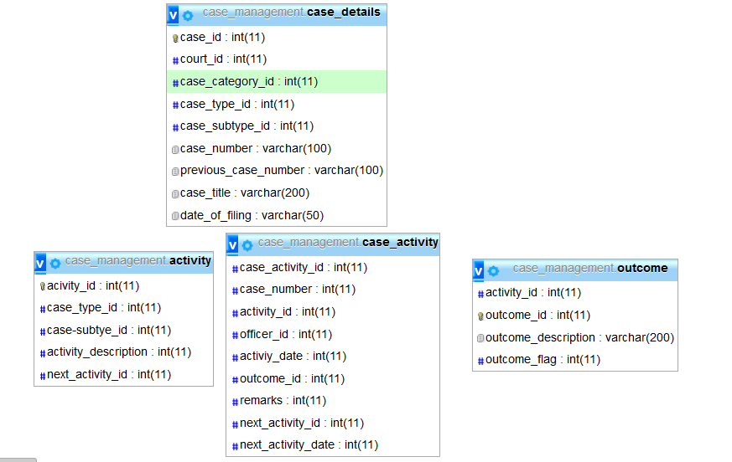 20

# DATABASE DICTIONARY

## COURT RANK

|  |  |
| --- | --- |
| **Rank Code** | **Court** |
| 01 | Supreme Court |
| 02 | Court of Appeal |
| 03 | High Court |
| 04 | Industrial Court |
| 05 | Environment and Land Court |
| 06 | Subordinate Court |
| 07 | Tribunials |

## COURT REGION

|  |  |  |
| --- | --- | --- |
| **CODE** | **REGION** | **HQ** |
| 001 | SOUTH COAST | MOMBASA |
| 002 | NORTH COAST | MALINDI |
| 003 | LOWER NORTH EASTERN | GARISA |
| 004 | UPPER NORTH EASTERN | WAJIR |
| 005 | UPPER EASTERN | ISIOLO |
| 006 | CENTRAL EASTERN | EMBU |
| 007 | LOWER EASTERN | KITUI |
| 008 | EASTERN CENTRAL | NYERI |
| 009 | WESTERN CENTRAL | THIKA |
| 010 | NORTH RIFT | ELDORET |
| 011 | CENTRAL RIFT | NAKURU |
| 012 | SOUTH RIFT | KERICHO |
| 013 | UPPER WESTERN | BUNGOMA |
| 014 | LOWER WESTERN | KAKAMEGA |
| 015 | NORTH NYANZA | KISUMU |
| 016 | NYANZA SOUTH | KISII |
| 017 | NAIROBI | NAIROBI |

## COURTS

|  |  |  |
| --- | --- | --- |
| **S No.** | **Court Stations** | **Unique ID** |
| 1 | Mombasa Court of Appeal | 010201 |
| 2 | Mombasa High Court | 010301 |
| 3 | Mombasa Industrial Court | 010401 |
| 4 | Mombasa Magistrate Court | 010601 |
| 5 | Tononoka Magistrate Court | 010602 |
| 6 | Shanzu Magistrate Court | 010603 |
| 7 | Kwale Magistrate Court | 020601 |
| 8 | Malindi Court of Appeal | 030201 |
| 9 | Malindi High Court | 030301 |
| 10 | Malindi Magistrate Court | 030601 |
| 11 | Mariakani Magistrate Court | 030602 |
| 12 | Kaloleni Magistrate Court | 030603 |
| 13 | Kilifi Magistrate Court | 030604 |
| 14 | Garsen Magistrate Court | 040601 |
| 15 | Hola Magistrate Court | 040602 |
| 16 | Lamu Magistrate Court | 050601 |
| 17 | Voi Magistrate Court | 060601 |
| 18 | Wundanyi Magistrate Court | 060602 |
| 19 | Taveta Magistrate Court | 060603 |
| 20 | Garissa High Court | 070301 |
| 21 | Garissa Magistrate Court | 070601 |
| 22 | Wajir Magistrate Court | 080601 |
| 23 | Mandera Magistrate Court | 090601 |
| 24 | Marsabit Magistrate Court | 100601 |
| 25 | Isiolo Magistrate Court | 110601 |
| 26 | Moyale Magistrate Court | 110602 |
| 27 | Meru MagistrateCourt | 120601 |
| 28 | Nkubu Magistrate Court | 120602 |
| 29 | Maua Magistrate Court | 120603 |
| 30 | Tigania Magistrate Court | 120604 |
| 31 | Chuka Magistrate Court | 130601 |
| 32 | Marimati Magistrate Court | 130602 |
| 33 | Embu Magistrate Court | 140601 |
| 34 | Runyenjes Magistrate Court | 140602 |
| 35 | Siakago Magistrate Court | 140603 |
| 36 | Kitui Magistrate Court | 150601 |
| 37 | Mutumo Magistrate Court | 150602 |
| 38 | Mwingi Magistrate Court | 150603 |
| 39 | Kyuso Magistrate Court | 150604 |
| 40 | Machakos Magistrate Court | 160601 |
| 41 | Kithimani Magistrate Court | 160602 |
| 42 | Kangundo Magistrate Court | 160603 |
| 43 | Makueni Magistrate Court | 170601 |
| 44 | Tawa Magistrate Court | 170602 |
| 45 | Kilungu/Nunguni Magistrate Court | 170603 |
| 46 | Makindu Magistrate Court | 170604 |
| 47 | Engineer Magistrate Court | 180601 |
| 48 | Nyeri Court of Appeal | 190201 |
| 49 | Nyeri High Court | 190301 |
| 50 | Nyeri Industrial Court | 190401 |
| 51 | Nyeri Magistrate Court | 190601 |
| 52 | Othaya Magistrate Court | 190602 |
| 53 | Karatina Magistrate Court | 190603 |
| 54 | Mukurwe-ini Magistrate Court | 190604 |
| 55 | Kirinyaga Magistrate Court | 200601 |
| 56 | Kerugoya High Court | 200302 |
| 57 | Kerugoya Magistrate Court | 200602 |
| 58 | Baricho Magistrate Court | 200603 |
| 59 | Gichugu Magistrate Court | 200604 |
| 60 | Wang’uru Magistrate Court | 200605 |
| 61 | Murang’a High Court | 210301 |
| 62 | Murang’a Magistrate Court | 210601 |
| 63 | Kangema Magistrate Court | 210602 |
| 64 | Kigumo Magistrate Court | 210603 |
| 65 | Kandara Magistrate Court | 210604 |
| 66 | Kiambu Magistrate Court | 220601 |
| 67 | Thika Magistrate Court | 220602 |
| 68 | Kikuyu Magistrate Court | 220605 |
| 69 | Limuru Magistrate Court | 220606 |
| 70 | Lodwar Magistrate Court | 230601 |
| 71 | Kakuma Magistrate Court | 230602 |
| 72 | Kapenguria Magistrate Court | 240601 |
| 73 | Maralal Magistrate Court | 250601 |
| 74 | Kitale High Court | 260301 |
| 75 | Kitale Magistrate Court | 260601 |
| 76 | Eldoret Court of Appeal | 270201 |
| 77 | Eldoret High Court | 270301 |
| 78 | Eldoret Magistrate Court | 270601 |
| 79 | Sotik Magistrate Court | 270602 |
| 80 | Iten Magistrate Court | 280601 |
| 81 | Kapsabet Magistrate Court | 290601 |
| 82 | Kabarnet Magistrate Court | 300601 |
| 83 | Nanyuki Magistrate Court | 310601 |
| 84 | Nyahururu Magistrate Court | 310602 |
| 85 | Nakuru High Court | 320301 |
| 86 | Naivasha High Court | 320302 |
| 87 | Nakuru Industrial Court | 320401 |
| 88 | Nakuru Magistrate Court | 320601 |
| 89 | Molo Magistrate Court | 320602 |
| 90 | Eldama Ravine Magistrate Court | 320603 |
| 91 | Naivasha Magistrate Court | 320604 |
| 92 | Narok Magistrate Court | 330601 |
| 93 | Kajiado Magistrate Court | 340601 |
| 94 | Kericho High Court | 350301 |
| 95 | Kericho Industrial Court | 350401 |
| 96 | Kericho Magistrate Court | 350601 |
| 97 | Bomet Magistrate Court | 360601 |
| 98 | Kakamega High Court | 370301 |
| 99 | Kakamega Magistrate Court | 370601 |
| 100 | Mumias Magistrate Court | 370602 |
| 101 | Butere Magistrate Court | 370603 |
| 102 | Butali Magistrate Court | 370604 |
| 103 | Vihiga Magistrate Court | 380601 |
| 104 | Hamisi Magistrate Court | 380602 |
| 105 | Bungoma High Court | 390301 |
| 106 | Bungoma Magistrate Court | 390601 |
| 107 | Webuye Magistrate Court | 390602 |
| 108 | Kimilili Magistrate Court | 390603 |
| 109 | Sirisia Magistrate Court | 390604 |
| 110 | Busia High Court | 400301 |
| 111 | Busia Magistrate Court | 400601 |
| 112 | Siaya Magistrate Court | 410601 |
| 113 | Bondo Magistrate Court | 410602 |
| 114 | Ukwala Magistrate Court | 410603 |
| 115 | Kisumu Court of Appeal | 420201 |
| 116 | Kisumu High Court | 420301 |
| 117 | Kisumu Industrial Court | 420401 |
| 118 | Kisumu Magistrate Court | 420601 |
| 119 | Winam Magistrate Court | 420602 |
| 120 | Maseno Magistrate Court | 420603 |
| 121 | Supreme Court | 470101 |
| 122 | Nairobi Court of Appeal | 470201 |
| 123 | Nairobi Industrial Court | 470401 |
| 124 | Kibera Magistrate Court | 470601 |
| 125 | Makadara Magistrate Court | 470602 |
| 126 | Milimani Magistrate Court | 470604 |
| 127 | Meru High Court | 120301 |
| 128 | Embu High Court | 140301 |
| 129 | Machakos High Court | 160301 |
| 130 | Mavoko Magistrate Court | 160604 |
| 131 | Homabay High Court | 430301 |
| 132 | Kisii High Court | 450301 |
| 133 | Migori High Court | 440601 |
| 134 | Homabay Magistrate Court | 430601 |
| 135 | Gatundu Magistrate Court | 220603 |
| 136 | Githunguri Magistrate Court | 220604 |
| 137 | Kehancha Magistrate Court | 440603 |
| 138 | Keroka Magistrate Court | 450602 |
| 139 | Kilgoris Magistrate Court | 330602 |
| 140 | Kisii Magistrate Court | 450301 |
| 141 | Migori Magistrate Court | 440601 |
| 142 | Ndhiwa Magistrate Court | 430603 |
| 143 | Nyamira Magistrate Court | 460601 |
| 144 | Nyando Magistrate Court | 420604 |
| 145 | Ogembo Magistrate Court | 450603 |
| 146 | Oyugis Magistrate Court | 430602 |
| 147 | Rongo Magistrate Court | 440602 |
| 148 | Tamu Magistrate Court | 420605 |
| 149 | Mbita Magistrate Court | 430604 |

## COUNTIES

|  |  |
| --- | --- |
| **Unique ID** | **County Name** |
| 001 | Mombasa |
| 002 | Kwale |
| 003 | Kilifi |
| 004 | Tana River |
| 005 | Lamu |
| 006 | Taita Taveta |
| 007 | Garissa |
| 008 | Wajir |
| 009 | Mandera |
| 010 | Marsabit |
| 011 | Isiolo |
| 012 | Meru |
| 013 | Tharaka Nithi |
| 014 | Embu |
| 015 | Kitui |
| 016 | Machakos |
| 017 | Makueni |
| 018 | Nyandarua |
| 019 | Nyeri |
| 020 | Kirinyaga |
| 021 | Murang'a |
| 022 | Kiambu |
| 023 | Turkana |
| 024 | West Pokot |
| 025 | Samburu |
| 026 | Trans Nzoia |
| 027 | Uasin Gishu |
| 028 | Elgeyo/Marakwet |
| 029 | Nandi |
| 030 | Baringo |
| 031 | Laikipia |
| 032 | Nakuru |
| 033 | Narok |
| 034 | Kajiado |
| 035 | Kericho |
| 036 | Bomet |
| 037 | Kakamega |
| 038 | Vihiga |
| 039 | Bung'oma |
| 040 | Busia |
| 041 | Siaya |
| 042 | Kisumu |
| 043 | Homa Bay |
| 044 | Migori |
| 045 | Kisii |
| 046 | Nyamira |
| 047 | Nairobi City |

**COURT DIVISIONS**

|  |  |
| --- | --- |
| **CODE** | **DIVISIONS** |
| 01 | CRIMINAL |
| 02 | CIVIL |
| 03 | FAMILY |
| 04 | JUDICIAL REVIEW |
| 05 | CONSTITUTIONAL AND HUMAN RIGHTS |
| 06 | ENVIRONMENT AND LAND |
| 07 | COMMERCIAL & ADMIRALTY |
| 08 | TRAFFIC |
| 09 | CHILDREN |
| 10 | KADHIS COURT CASE |
| 11 | CITY COURT |
| 12 | MOBILE COURT |
| 13 | COMMERCIAL COURT |

## CASE CATEGORY

|  |  |  |
| --- | --- | --- |
| **Code** | **Name** | **Description** |
| 1. | SCPET | Supreme Court Petition |
| 2. | SCADV | Supreme Court Advisory Opinion |
| 3. | SCAPP | Supreme Court Application |
| 4. | CA | Civil Appeal |
| 5. | CAPPL | Civil Application |
| 6. | ELC | Environment and Land |
| 7. | HCCC | High Court Civil Case |
| 8. | HCCR | High Court Criminal Case |
| 9. | HCCA | High Court Civil Appeal |
| 10. | HCCRA | High Court Criminal Appeal |
| 11. | ELRC | Employment and labour Relations Case |
| 12. | KCC | Kadhis Civil Case |
| 13. | MCCC | Magistrate Civil Case |
| 14. | MCCR | Magistrate Criminal Case |
| 15. | MCTR | Magistrate Traffic Case |

## CASE TYPE

|  |  |  |
| --- | --- | --- |
| **Code** | **Type Name** | **Description** |
| 1 | ABORTION | Abortion, infanticide, concealing birth, killing unborn child |
| 2 | ADOPTION | Adoption |
| 3 | PUBLICATIONS | Alarming publications |
| 4 | ARSON | Arson, setting fire to crops and offences allied to arson |
| 5 | ATTEMPTED MURDER | Attempted murder, suicide and related offenses |
| 6 | ATTEMPTED ROBBERY | Attempted robbery |
| 7 | BANKRUPTCY | Bankruptcy and Winding Up Causes |
| 8 | BURGLARY | Burglary, housebreaking, entering dwelling-house with intent to commit felony and similar offences |
| 9 | CHILD CONFLICT LAW | Child in conflict with the law |
| 10 | CHILD STEALING | Child stealing |
| 11 | CHILD CARE AND PROTECTION | Children in need of care and protection, including orphaned and vulnerable children, children subjected to harmful cultural practices (FGM and early marriages), torture, prostitution, trafficking, and other offenses under the Children's Act |
| 12 | CIVIL APPEAL | Civil Appeal |
| 13 | CBAS | Collective Bargaining Agreements (CBAs) |
| 14 | COMMERCIAL | Commercial |
| 15 | CONSTITUTIONAL | Constitutional and Human Rights Petitions (including Constitutional References) |
| 16 | INTEGRITY | Corruption and integrity |
| 17 | TRADEMARKS | Counterfeiting trademarks |
| 18 | PUBLIC TRANQUILITY | Creating disturbance, drunk and disorderly, affray, unlawful assembly, riots, and other offenses against public tranquility |
| 19 | CRIMINAL APPEAL | Criminal Appeal |
| 20 | CRIMINAL NEGLIGENCE | Criminal negligence, recklessness, nuisances |
| 21 | CRIMINAL REVISION | Criminal Revision |
| 22 | CRIMINAL TRESPASS | Criminal Trespass, forcible detainer |
| 23 | DIVORCE | Divorce |
| 24 | ELC | Environment and Land Cases (ELC) |
| 25 | ELC APPEALS | ELC Appeals |
| 26 | ELC MISCELLANEOUS | ELC Miscellaneous Cases |
| 27 | ELECTION PETITIONS | Election petitions |
| 28 | FRAUD | Fraud, forgery (including coining), obtaining by false pretenses, treachery, personation, frauds by trustees and persons in a position of trust and false accounting |
| 29 | ASSAULT | Grievous harm, assault causing actual bodily harm, common assault |
| 30 | INCOME TAX APPEALS | Income Tax Appeals |
| 31 | INDUSTRIAL CAUSES | Industrial Causes |
| 32 | INDUSTRIAL JUDICIAL REVIEW | Industrial Judicial Review |
| 33 | INDUSTRIAL MISCELLANEOUS | Industrial Miscellaneous |
| 34 | INDUSTRIAL PETITIONS | Industrial Petitions |
| 35 | INQUEST | Inquest |
| 36 | JUDICIAL REVIEW | Judicial Review |
| 37 | KHADI DIVORCE | Kadhi divorce |
| 38 | KHADI MATTERS | Kadhi- other matters (capture in details of case) |
| 39 | KHADI SUCCESSION | Kadhi succession |
| 40 | ABDUCTION | Kidnapping, abduction, detention of female for immoral purposes |
| 41 | LIBEL | Libel, defamation, slander |
| 42 | MALICIOUS DAMAGE | Malicious damage, injury to property, goods etc. |
| 43 | MANSLAUGHTER | Manslaughter |
| 44 | MATRIMONIAL PROPERTY DISPUTE | Matrimonial property dispute |
| 45 | MISCELLANEOUS CIVIL APPLICATION | Miscellaneous Civil Applications |
| 46 | MISCELLANEOUS COMMERCIAL APPLICATION | Miscellaneous Commercial Applications |
|  |  |  |
| 47 | MISCELLANEOUS CRIMINAL APPLICATION | Miscellaneous Criminal Applications |
| 48 | MURDER | Murder |
| 49 | OBSTRUCTION OF JUSTICE | Obstruction of justice: perjury, conspiracy to defeat justice, escapes from custody, resisting arrest and miscellaneous offenses against the administration of justice and public authority |
| 50 | IMMORAL OFFENCES | Offences allied to morality including prostitution, bigamy, marriage with fraudulent intent |
| 51 | LICENSING OFFENCES | Offences relating to alcoholic drinks control and licensing |
| 52 | PUBLIC HEALTH OFFENCES | Offenses under Public Health Act |
| 53 | PERSONAL INJURY | Personal injury (Running down) |
| 54 | WORKMEN COMPENSATION | Personal injury (Workmen's Compensation) |
| 55 | FIREARM POSSESSION | Possession of firearms, explosives and related |
| 56 | NARCOTIC POSSESSION | Possession of narcotic drugs and psychotropic substances (cannabis sativa, cocaine, heroin etc.) |
| 57 | CONSPIRACY AND UNLAWFULLY OATHS | Preparations/conspiracy to commit felony, neglect to prevent a felony, unlawful oaths, threats to kill |
| 58 | ROBBERY | Robbery |
| 59 | ROBBERY WITH VIOLENCE | Robbery with violence |
| 60 | SEXUAL OFFENCES | Sexual offenses (defilement, attempted defilement, rape, gang rape, incest, indecent acts with a child or adult, sexual harassment and others) |
| 61 | LIVESTOCK THEFT AND INJURY | Stock theft, and injuring, killing or maiming of a domestic animal with intent to steal |
| 62 | SUCCESSION | Succession (Probate & Administration - P&A) |
| 63 | TERRORISM | Terrorism, piracy and related offenses |
| 64 | THEFT OF GOODS | Theft, stealing by servant, handling stolen or suspected stolen property/goods, possession of government/public stores, and related offenses |
| 65 | TRAFFIC | Traffic |
| 66 | WILDLIFE OFFENCES | Wildlife and forestry offenses |
| 67 | OTHERS CIVIL | Other civil- (specify in details of case) |
| 68 | OTHERS CRIMINAL | Other criminal- (specify in details of case) |

## COURT ACTION CODES

|  |  |
| --- | --- |
| **Court action** | **Id** |
| Registration/Filing | 1 |
| Hearing | 2 |
| Mention | 3 |
| Ruling | 4 |
| Judgement | 5 |
| Pre Trial Conference (Case Management Conference) | 6 |
| Taxation | 7 |

# SYSTEM MODULE FIELDS

## CASE REGISTRATION

* Case Number
* Date of filing
* Citation
* Case type
* Case Subtype
* Case status (active, closed, archived, disposed)

### Parties

Type of party (**witness, respondent/defendant, petitioner/plaintiff, advocate, accused, probation officer)**

* Full Name
* Mobile Number
* Gender
* Physical Address
* Postal Address
* Nationality
* Occupation
* Name of Law Firm (If advocate)
* Force Number of Investigating officer)

## CASE TRACKING

* Name of activity
* Activity Date
* Actors (DR, Judicial Officers)
* Outcome
* Next activity
* Date of next activity
* Bench for next activity

## COURT FEES

* Payment type (bond, bail, fine, fees)
* Assessment Date
* Assessed by
* Amount assessed
* Transaction type (Bank, Mobile money)
* Amount paid
* Date paid
* Paid in by

## E-FILING

* Type of document
* Name of document
* Submitted by (Name)
* Submitted by(Relation to case
* Date submitted

## File Movement

* Case file number
* Moving from
* Moved by
* Moving for what?
* Date/Time moving
* Moving to where
* Moving to who
* Date/Time received
* Received by who
* Date returned

## EXHIBITS MANAGEMENT

* Category of the Exhibit e.g. narcotics and alcoholic drinks, Forest and wildlife products, Motor vehicle, Perishable, non perishable

### Exhibit number

### Date exhibit produced

### Witness name

### Estimated value

### Photograph of the exhibit

### Disposal orders attachment

### Disposal order date

### Exhibit Returned To : Name, Identification Number

### Exhibit Returned Date

### Remarks

## FIELDS UNIQUE TO VARIOUS CASE TYPES:

## High Court Criminal

### Murder cases

* Date of registration of the Information
* The charge(s)
* Name of the deceased
* Relationship of accused and the deceased
* Gender of the accused person(s)
* Gender of the deceased person(s)
* Age of accused (adult, minor)

### Criminal Appeals

* Case number in lower court
* Name of lower court
* Name(s) of judicial officers in case
* Ruling delivered in lower court
* Dates ruling made in lower court

### Criminal Revisions

* Case number in lower court
* Name of lower court
* Name(s) of judicial officers in case
* Ruling delivered in lower court
* Dates ruling made in lower court

### Misc. Applications in Criminal Matters

* Nature of application
* Description
* Parties

## Family division

### Probate and Administration

* Value of estate
* Name of deceased
* Residence of deceased
* Citizenship of Deceased
* Place of domicile
* Date of Death
* Death Certificate Entry Number
* Death Certificate Serial Number

### Divorce

* Place of marriage
* Place and date of marriage
* Marriage Certificate number
* Names and dates of birth of the child(ren)
* Domiciles of the parties
* Occupations of parties
* Details of any related previous proceedings.
* Matrimonial offenses alleged

## SYSTEM USERS

* + - User Class 1- Registry Users (Court Assistants, E.O)

-PROFILE

* + - User Class 2 – Judicial Administrators (DR, HOD, Presiding Judge)

- PROFILE

* + - User Class 3 – Judicial Officers (Judges, Magistrates)

PROFILE

* + - User Class 4 – ICT Administrators (ICTO, ICT Director)

-PROFILE

## Audit Trail

* User ID
* Date & Time
* IP of the User
* User Activities

## CASE STATUS

|  |  |
| --- | --- |
| **Category** | **Status ID** |
| Active status | 0 |
| Closed status | 1 |
| Archived status | 2 |
| Disposed status | 3 |

## DESIGN OVERVIEW FOR A FEW TABLES

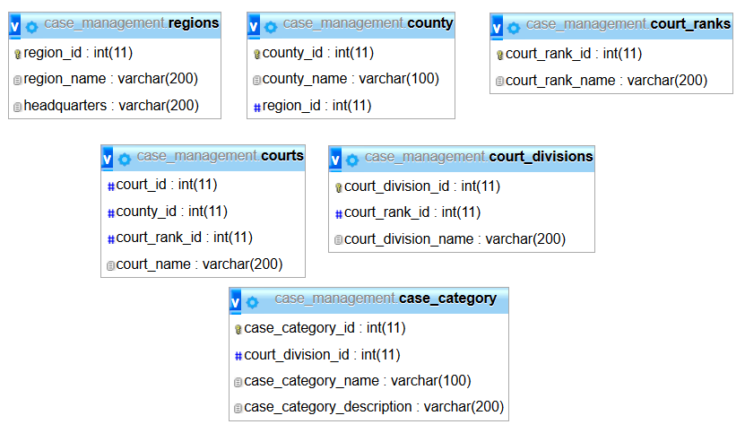

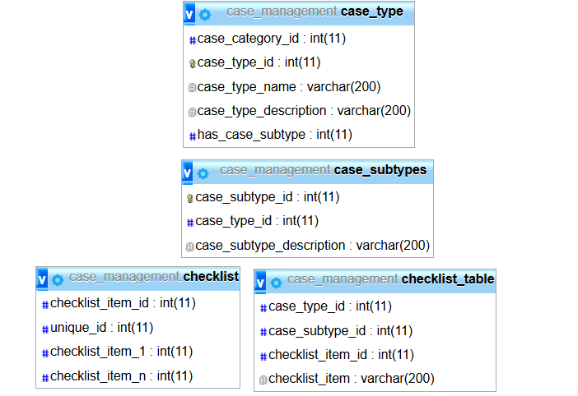

# 3.PNG

